Instructions on how to fill out the new Web-Based IT Requisition Form

Start by filling in out your name in the field “Requested By”, your email will be filled automatically and the date in which this request is needed in the field “Date needed” (The default date is set to 3 weeks from today’s date). To enter a different date click on the field and select one from the dropdown calendar that appears.

NOTE: All fields marked with an asterisk (*) are required.

The “Requested By” and “This request is for the following employee(s):” fields have an auto complete feature. When you start typing the name in the field you will see a drop down with the names that match the letters you type. Select one from the list. If the name you want is not on the list this person does not exist within our system; in that case just type the complete name and ignore the drop down.

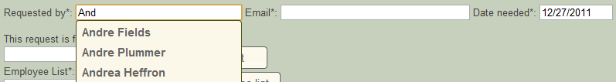
The field “Date needed” will be automatically filled with the date 3 weeks from today’s date.
The auto complete drop down.

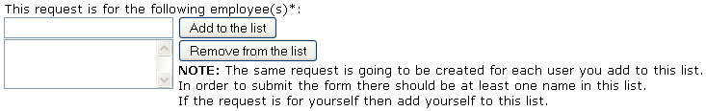

Next you need to create a list of users for whom this request is being made. Write the name of the person in the box and select “Add to the list”. To remove a name from the list, highlight it and then select “Remove from the list”

The next step is to select the request type. Each request type will require you to fill in a particular section of the form. These sections only show up when you select that type. For example if you select “New Software” you will only see the section of the form that is relevant to this selection. Note that you can select more than one request type.

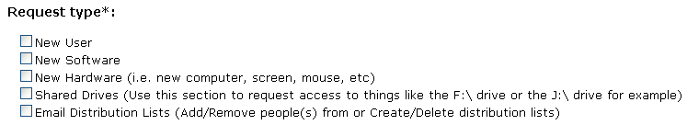

Sections

New User

Legal name should be the complete name of the new employee as HR has it on file. Select a location from the list. Select Remote/Home User for users that do not have an assigned desk at any EF location. Select Other Location for users that don’t work from home but their location is not listed.

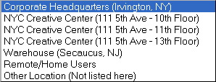
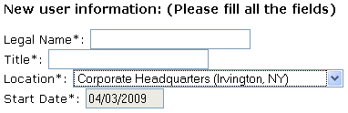

The field “Start Date” will automatically be filled with a date 3 days from the “Date Needed”. We want to have everything ready at least 3 days before this new employee starts. If this employee is starting on a different date click on the field and select a date using the dropdown calendar.

New Software

When you select “New Software” as a request type, you will see this section of the form:
Make a selection of the software that you need or select other, and enter the name(s) of the software you need. A reason is required for new software.

NOTE:
If you select BlueCherry a copy of your approved request will be sent to the BlueCherry Support Team.
If you select WebPDM a copy of the approved request will be sent to the WebPDM Administrator.

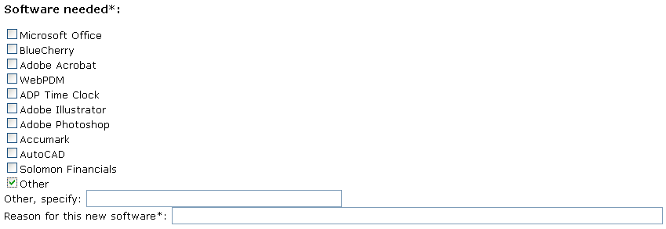

New Hardware

When you select “New Hardware” as a request type, you will see this section of the form:
You can only select a laptop or a desktop, not both. You can select multiple choices of the other hardware selections. If the hardware you need is not listed select other and type the name of the hardware. A reason is required for new hardware.

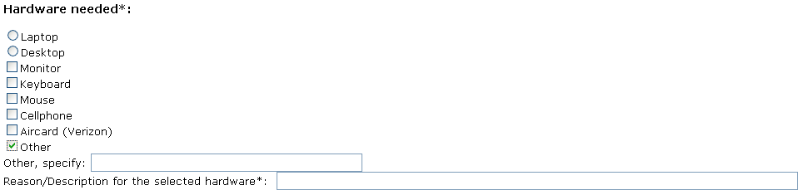

Shared Drives

If access is required to a network folder/drive then select this option and fill the relevant information below.
In this box type the drive and or path to the folder that you need access to, and then select “Add to the List”. You can add as many folders as you need to this list.

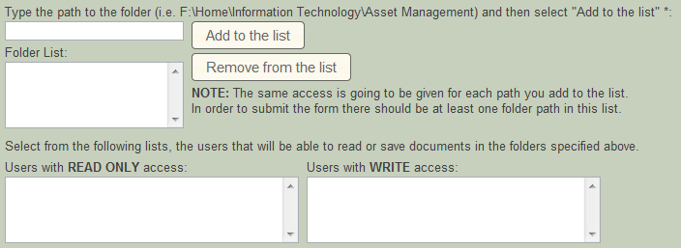
You will see here the same list of users that you added before in the first part of the form (For User(s): ).
Select the users that need the corresponding permissions. On the LEFT select the users that will only get READ access and on the RIGHT select the users that will get WRITE access.

Email Distribution Lists

Use this section to request the creation and deletion of distribution lists. Also use this section if you need to add or remove employees from existing distribution lists. This section is divided into four subsections. After selecting the ones you are interested in, the relevant sections will appear beneath the checkboxes.

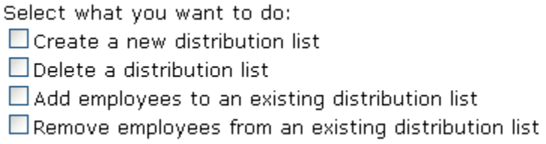
The “Request list” aggregates all the requests from each subsection, if you've made a mistake or don't need a particular request, you can remove it from the list by highlighting it and then selecting “Remove request”.
NOTE: There can be any number of requests in this list, including unlimited of each subsection, even if all are from the same subsection.

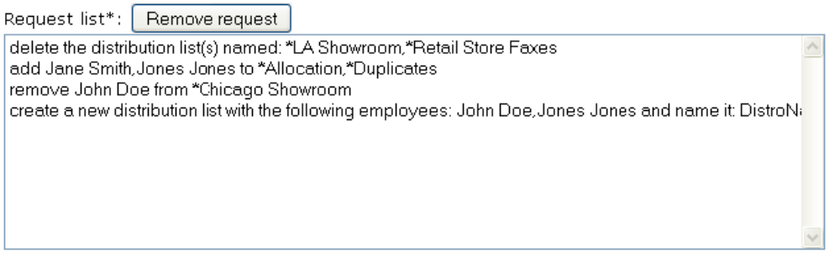
The example requests shown are the result of the actions in each subsection below.

Email Distribution Lists – Create a new Distribution List

Type in the box a name for the new distribution list; highlight the employees that will be added to it and then select “Add Request”. A new line will be added to the “Request List” (e.g. create a new distribution list with the following employees: John Doe,Jones Jones and name it: DistroName)

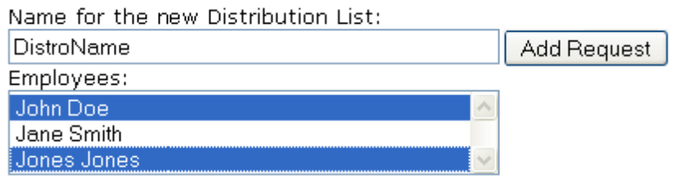
Email Distribution Lists – Delete a Distribution List

Highlight the distribution list(s) that you need to delete and select “Add Request”. A new line will be added to the “Request List” (e.g. delete the distribution list(s) named: *LA Showroom,*Retail Store Faxes)

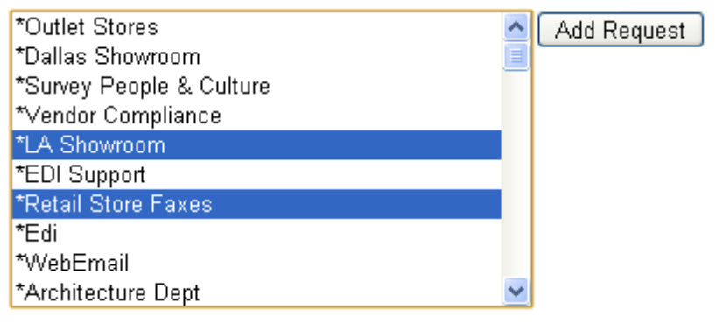
Email Distribution Lists – Add people to an existing Distribution List

Highlight the employees and the distribution list(s) and then select “Add Request”. All highlighted employees will be added to all highlighted distribution lists. (e.g. add Jane Smith, Jones Jones to *Allocation,*Duplicates)
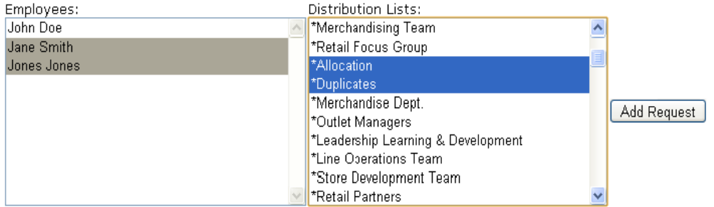
Email Distribution Lists – Remove people from an existing Distribution List

Highlight the employees and the distribution list(s) and then select “Add Request”. All highlighted employees will be removed from all highlighted distribution lists. (e.g. remove John Doe from *Chicago Showroom)
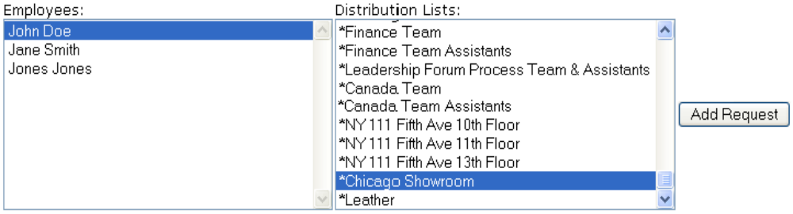

Signature

At the bottom of the form there is a section for the signature. First select your Department/Account to be charged and then type in your manager’s name and email. Note that these two boxes have the auto-complete feature like the ones at the beginning. You can make selections form the list or complete them manually.

NOTE: This section is required. If the form is not signed it will not be processed. Your manager, will receive an email with a copy of the form and he/she will have the opportunity to make changes to your request. Your request will not be processed by I.T. until your manager approves it.

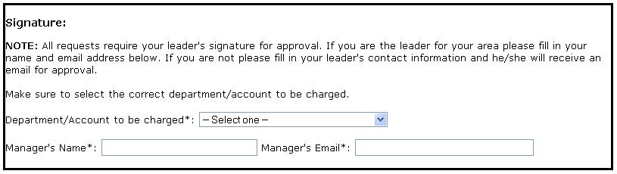

If your manager approves your request you will receive a copy of the form as a confirmation that it was approved and a copy of the completed form will be sent to the helpdesk.

- Managers will have up to 60 days to approve requisition forms, after 60 days your form will expire and will be deleted.
- Managers can make changes to the request before approving it.
- Once your manager approves and submits your requisition form, it cannot be modified electronically. For help with making changes to submitted requisition forms please contact the helpdesk.

We hope that this will make it easier for everyone to file requisition forms. If you have any problems with the form please contact the helpdesk.

Thank you

